GamWhich are the playing characters of this game?

* Playing characters are the ones which respond to the user based on the input from the user
* Cars, monkeys, dinos, wizards etc., are the playing characters in the game.

|  |  |  |
| --- | --- | --- |
| Number | Character Name | What can this character do? |
| 1 | Harry |  |
| 2 |  |  |
| 3 |  |  |
| 4 |  |  |
| 5 |  |  |
| 6 |  |  |
| 7 |  |  |
| 8 |  |  |

1. Which are the Non Playing Characters of this game?

* Non Playing characters are the ones which don't have an action or a behaviour when the user interacts with the game.
* Hurdles, stones, bananas, coins, etc are non playing characters in the game.

|  |  |  |
| --- | --- | --- |
| Number | Character Name | What can this character do? |
| 1 | Lions |  |
| 2 | Serial Killer |  |
| 3 | lava |  |
| 4 | water |  |
| 5 | fire |  |
| 6 | ice |  |
| 7 | Deadly big spider |  |
| 8 |  |  |

Draw your imagination of this game. What does this game look like?

* Draw the game either on your computer or on paper,
* Add images of scenes of the game to show each of the playing and non-playing characters at least once.

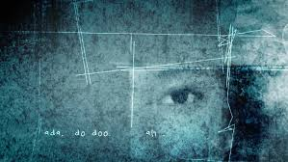

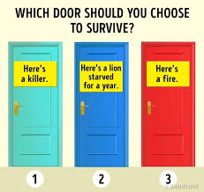

How do you plan to make your game engaging?

*intensifying thriller sound tracks,

* intensifying thriller background